The connectivity of the human frontal pole cortex, and a theory of its involvement in exploit vs explore

Supplementary Material

Cerebral Cortex (2024) 34: 1-19. doi: 10.1093/cercor/bhad416

Edmund T. Rolls^{1, 2, 6*}, Gustavo Deco^{3,4}, Chu-Chung Huang⁵, Jianfeng Feng^{2,6}

- Oxford Centre for Computational Neuroscience, Oxford, UK
- Department of Computer Science, University of Warwick, Coventry, CV4 7AL, UK
- Center for Brain and Cognition, Computational Neuroscience Group, Department of Information and Communication Technologies, Universitat Pompeu Fabra, Roc Boronat 138, Barcelona, 08018, Spain; Brain and Cognition, Pompeu Fabra University, Barcelona, 08018, Spain.
- Institució Catalana de la Recerca i Estudis Avançats (ICREA), Universitat Pompeu Fabra, Passeig Lluís Companys 23, Barcelona, 08010, Spain.
- Shanghai Key Laboratory of Brain Functional Genomics (Ministry of Education), Institute of Brain and Education Innovation, School of Psychology and Cognitive Science, East China Normal University, Shanghai 200602, China; and Shanghai Center for Brain Science and Brain-Inspired Technology, Shanghai 200602, China.
- Institute of Science and Technology for Brain Inspired Intelligence, Fudan University, Shanghai 200403, China

*Corresponding author information:
Professor Edmund T. Rolls,
Department of Computer Science, University of Warwick, Coventry CV4 7AL, UK. Email: Edmund.Rolls@oxcns.org
URL: https://www.oxcns.org
https://orcid.org/0000-0003-3025-1292

Modified ordering of the HCP-MMP atlas
The atlas used to define brain regions was the HCP-MMP surface-based atlas (Glasser et al. 2016), illustrated in Figs. 6-10 and S1. In the HCP-MMP atlas, each region has its RegionID, which we show in Table S1. Detailed information about the regions is available in the Supplementary Material File NIHMS68870-supplement-Neuroanatomical_Supplementary_Results.pdf provided by Glasser et al (2016). In that Supplementary Material file, a grouping of the regions is suggested based on geographic proximity and functional similarities, and this grouping is shown in the column labelled CortexID in Table S1. That has led to a different ordering of the regions, which we show in Table S1, with the original regionIDs from the HCP atlas shown in the column headed ‘regionID’. This reordered version of the HCP-MMP atlas is described by Dr Dianne Patterson of the University of Arizona at https://neuroimaging-core-docs.readthedocs.io/en/latest/pages/atlases.html, where the following supporting files used to help generate Table S1 are available: HCP-MMP_UniqueRegionList.csv and Glasser_2016_Table.xlsx. We made file HCPMMP_CortexID_Ordering.xlsx from this, and this is available from the present authors. The connectivity matrices shown in the present paper used the ordering shown in Table S1, which is also used in the volumetric and extended form of this atlas (Huang et al. 2022).

Table S1. Regions defined in the modified Human Connectome Project atlas (Glasser et al. 2016). L=left hemisphere, R=right. The column ‘Reordered region ID’ is that used in Figs. 1-5, and is a reordering of that based on suggestions in the Supplementary Information of Glasser et al (2016). In that Supplementary Information of that paper, the 360 regions are grouped based on geographic proximity and functional similarities, which was reorganized and provided by Dr Dianne Patterson of the University of Arizona at https://neuroimaging-core-docs.readthedocs.io/en/latest/pages/atlases.html with the HCP-MMP_UniqueRegionList.csv and is shown in the column labelled CortexID in Table S1. The volumes are in mm³. This modified atlas with the reordering is described elsewhere (Huang et al. 2022).

Reordered  ID (L, R) | Region | RegionLongName | Cortical Division | Cortex  ID | Original  ID | Voxel numbers (1mm³) (L,R)
1, 181 | V1 | Primary_Visual_Cortex | Primary_Visual | 1 | 1 | 13812, 13406
2, 182 | V2 | Second_Visual_Area | Early_Visual | 2 | 4 | 9515, 9420
3, 183 | V3 | Third_Visual_Area | Early_Visual | 2 | 5 | 7106, 7481
4, 184 | V4 | Fourth_Visual_Area | Early_Visual | 2 | 6 | 4782, 4537
5, 185 | IPS1 | IntraParietal_Sulcus_Area_1 | Dorsal_Stream_Visual | 3 | 17 | 1751, 1750
6, 186 | V3A | Area_V3A | Dorsal_Stream_Visual | 3 | 13 | 2191, 2212
7, 187 | V3B | Area_V3B | Dorsal_Stream_Visual | 3 | 19 | 639, 731
8, 188 | V6 | Sixth_Visual_Area | Dorsal_Stream_Visual | 3 | 3 | 1402, 1559
9, 189 | V6A | Area_V6A | Dorsal_Stream_Visual | 3 | 152 | 904, 734
10, 190 | V7 | Seventh_Visual_Area | Dorsal_Stream_Visual | 3 | 16 | 1005, 1041
11, 191 | FFC | Fusiform_Face_Complex | Ventral_Stream_Visual | 4 | 18 | 3848, 4402
12, 192 | PIT | Posterior_InferoTemporal_complex | Ventral_Stream_Visual | 4 | 22 | 1392, 1386
13, 193 | V8 | Eighth_Visual_Area | Ventral_Stream_Visual | 4 | 7 | 1361, 1175
14, 194 | VMV1 | VentroMedial_Visual_Area_1 | Ventral_Stream_Visual | 4 | 153 | 939, 1219
15, 195 | VMV2 | VentroMedial_Visual_Area_2 | Ventral_Stream_Visual | 4 | 160 | 639, 923
16, 196 | VMV3 | VentroMedial_Visual_Area_3 | Ventral_Stream_Visual | 4 | 154 | 941, 1242
17, 197 | VVC | Ventral_Visual_Complex | Ventral_Stream_Visual | 4 | 163 | 2487, 2753
18, 198 | FST | Area_FST | MT+_Complex | 5 | 157 | 1324, 1683
19, 199 | LO1 | Area_Lateral_Occipital_1 | MT+_Complex | 5 | 20 | 619, 909
20, 200 | LO2 | Area_Lateral_Occipital_2 | MT+_Complex | 5 | 21 | 1179, 1062
21, 201 | LO3 | Area_Lateral_Occipital_3 | MT+_Complex | 5 | 159 | 438, 915
22, 202 | MST | Medial_Superior_Temporal_Area | MT+_Complex | 5 | 2 | 794, 1036
23, 203 | MT | Middle_Temporal_Area | MT+_Complex | 5 | 23 | 620, 1005
24, 204 | PH | Area_PH | MT+_Complex | 5 | 138 | 3453, 3205
25, 205 | V3CD | Area_V3CD | MT+_Complex | 5 | 158 | 876, 1222
26, 206 | V4t | Area_V4t | MT+_Complex | 5 | 156 | 1037, 1249
27, 207 | 1 | Area_1 | SomaSens_Motor | 6 | 51 | 6590, 5925
28, 208 | 2 | Area_2 | SomaSens_Motor | 6 | 52 | 4278, 4727
29, 209 | 3a | Area_3a | SomaSens_Motor | 6 | 53 | 2247, 2286
30, 210 | 3b | Primary_Sensory_Cortex | SomaSens_Motor | 6 | 9 | 5451, 4350
31, 211 | 4 | Primary_Motor_Cortex | SomaSens_Motor | 6 | 8 | 10776, 10254
32, 212 | 23c | Area_23c | ParaCentral_MidCing | 7 | 38 | 2259, 2498
33, 213 | 24dd | Dorsal_Area_24d | ParaCentral_MidCing | 7 | 40 | 2665, 2820
34, 214 | 24dv | Ventral_Area_24d | ParaCentral_MidCing | 7 | 41 | 1076, 1349
35, 215 | 5L | Area_5L | ParaCentral_MidCing | 7 | 39 | 2249, 2327
36, 216 | 5m | Area_5m | ParaCentral_MidCing | 7 | 36 | 1483, 2079
37, 217 | 5mv | Area_5m_ventral | ParaCentral_MidCing | 7 | 37 | 1651, 1996
38, 218 | 6ma | Area_6m_anterior | ParaCentral_MidCing | 7 | 44 | 3941, 4251
39, 219 | 6mp | Area_6mp | ParaCentral_MidCing | 7 | 55 | 3701, 3105
40, 220 | SCEF | Supplementary_and_Cingulate_Eye_Field | ParaCentral_MidCing | 7 | 43 | 3500, 3371
41, 221 | 55b | Area_55b | Premotor | 8 | 12 | 2422, 1537
42, 222 | 6a | Area_6_anterior | Premotor | 8 | 96 | 4233, 3752
43, 223 | 6d | Dorsal_area_6 | Premotor | 8 | 54 | 2916, 2909
44, 224 | 6r | Rostral_Area_6 | Premotor | 8 | 78 | 3029, 3981
45, 225 | 6v | Ventral_Area_6 | Premotor | 8 | 56 | 2075, 2516
46, 226 | FEF | Frontal_Eye_Fields | Premotor | 8 | 10 | 1787, 1889
47, 227 | PEF | Premotor_Eye_Field | Premotor | 8 | 11 | 1006, 1258
48, 228 | 43 | Area_43 | Posterior_Opercular | 9 | 99 | 1889, 1678
49, 229 | FOP1 | Frontal_Opercular_Area_1 | Posterior_Opercular | 9 | 113 | 879, 932
50, 230 | OP1 | Area_OP1-SII | Posterior_Opercular | 9 | 101 | 1275, 1072
51, 231 | OP2-3 | Area_OP2-3-VS | Posterior_Opercular | 9 | 102 | 943, 792
52, 232 | OP4 | Area_OP4-PV | Posterior_Opercular | 9 | 100 | 2332, 2409
53, 233 | 52 | Area_52 | Early_Auditory | 10 | 103 | 725, 580
54, 234 | A1 | Primary_Auditory_Cortex | Early_Auditory | 10 | 24 | 1023, 796
55, 235 | LBelt | Lateral_Belt_Complex | Early_Auditory | 10 | 174 | 820, 901
56, 236 | MBelt | Medial_Belt_Complex | Early_Auditory | 10 | 173 | 1242, 1236
57, 237 | PBelt | ParaBelt_Complex | Early_Auditory | 10 | 124 | 1719, 1439
58, 238 | PFcm | Area_PFcm | Early_Auditory | 10 | 105 | 1486, 1485
59, 239 | RI | RetroInsular_Cortex | Early_Auditory | 10 | 104 | 1149, 1334
60, 240 | A4 | Auditory_4_Complex | Auditory_Association | 11 | 175 | 3514, 3610
61, 241 | A5 | Auditory_5_Complex | Auditory_Association | 11 | 125 | 3346, 3881
62, 242 | STGa | Area_STGa | Auditory_Association | 11 | 123 | 2509, 2187
63, 243 | STSda | Area_STSd_anterior | Auditory_Association | 11 | 128 | 1944, 2389
64, 244 | STSdp | Area_STSd_posterior | Auditory_Association | 11 | 129 | 1994, 2605
65, 245 | STSva | Area_STSv_anterior | Auditory_Association | 11 | 176 | 1694, 1900
66, 246 | STSvp | Area_STSv_posterior | Auditory_Association | 11 | 130 | 2898, 2515
67, 247 | TA2 | Area_TA2 | Auditory_Association | 11 | 107 | 1518, 1726
68, 248 | AAIC | Anterior_Agranular_Insula_Complex | Insula_FrontalOperc | 12 | 112 | 1859, 1691
69, 249 | AVI | Anterior_Ventral_Insular_Area | Insula_FrontalOperc | 12 | 111 | 1446, 1792
70, 250 | FOP2 | Frontal_Opercular_Area_2 | Insula_FrontalOperc | 12 | 115 | 750, 720
71, 251 | FOP3 | Frontal_Opercular_Area_3 | Insula_FrontalOperc | 12 | 114 | 754, 614
72, 252 | FOP4 | Frontal_Opercular_Area_4 | Insula_FrontalOperc | 12 | 108 | 2522, 1678
73, 253 | FOP5 | Area_Frontal_Opercular_5 | Insula_FrontalOperc | 12 | 169 | 1297, 1365
74, 254 | Ig | Insular_Granular_Complex | Insula_FrontalOperc | 12 | 168 | 841, 1077
75, 255 | MI | Middle_Insular_Area | Insula_FrontalOperc | 12 | 109 | 2102, 1960
76, 256 | PI | Para-Insular_Area | Insula_FrontalOperc | 12 | 178 | 1033, 1058
77, 257 | Pir | Piriform_Cortex | Insula_FrontalOperc | 12 | 110 | 2287, 1856
78, 258 | PoI1 | Area_Posterior_Insular_1 | Insula_FrontalOperc | 12 | 167 | 1811, 1835
79, 259 | PoI2 | Posterior_Insular_Area_2 | Insula_FrontalOperc | 12 | 106 | 2747, 2675
80, 260 | H | Hippocampus | Medial_Temporal | 13 | 120 | 4283, 3626
81, 261 | PreS | PreSubiculum | Medial_Temporal | 13 | 119 | 1817, 1558
82, 262 | EC | Entorhinal_Cortex | Medial_Temporal | 13 | 118 | 2127, 2110
83, 263 | PeEc | Perirhinal_Ectorhinal_Cortex | Medial_Temporal | 13 | 122 | 4826, 4755
84, 264 | TF | Area_TF | Medial_Temporal | 13 | 135 | 3986, 4752
85, 265 | PHA1 | ParaHippocampal_Area_1 | Medial_Temporal | 13 | 126 | 1281, 1168
86, 266 | PHA2 | ParaHippocampal_Area_2 | Medial_Temporal | 13 | 155 | 783, 771
87, 267 | PHA3 | ParaHippocampal_Area_3 | Medial_Temporal | 13 | 127 | 2023, 1122
88, 268 | PHT | Area_PHT | Lateral_Temporal | 14 | 137 | 4182, 3410
89, 269 | TE1a | Area_TE1_anterior | Lateral_Temporal | 14 | 132 | 5227, 4180
90, 270 | TE1m | Area_TE1_Middle | Lateral_Temporal | 14 | 177 | 3339, 3429
91, 271 | TE1p | Area_TE1_posterior | Lateral_Temporal | 14 | 133 | 7116, 6010
92, 272 | TE2a | Area_TE2_anterior | Lateral_Temporal | 14 | 134 | 5691, 5753
93, 273 | TE2p | Area_TE2_posterior | Lateral_Temporal | 14 | 136 | 4115, 3040
94, 274 | TGd | Area_TG_dorsal | Lateral_Temporal | 14 | 131 | 10192, 10269
95, 275 | TGv | Area_TG_Ventral | Lateral_Temporal | 14 | 172 | 3694, 4515
96, 276 | PSL | PeriSylvian_Language_Area | TPO | 15 | 25 | 2154, 2759
97, 277 | STV | Superior_Temporal_Visual_Area | TPO | 15 | 28 | 2322, 2294
98, 278 | TPOJ1 | Area_TemporoParietoOccipital_Junction_1 | TPO | 15 | 139 | 2102, 3938
99, 279 | TPOJ2 | Area_TemporoParietoOccipital_Junction_2 | TPO | 15 | 140 | 1930, 2068
100, 280 | TPOJ3 | Area_TemporoParietoOccipital_Junction_3 | TPO | 15 | 141 | 1290, 1277
101, 281 | 7AL | Lateral_Area_7A | Superior_Parietal | 16 | 42 | 2134, 2030
102, 282 | 7Am | Medial_Area_7A | Superior_Parietal | 16 | 45 | 2995, 2379
103, 283 | 7PC | Area_7PC | Superior_Parietal | 16 | 47 | 3151, 3415
104, 284 | 7PL | Lateral_Area_7P | Superior_Parietal | 16 | 46 | 1695, 1363
105, 285 | 7Pm | Medial_Area_7P | Superior_Parietal | 16 | 29 | 1601, 1308
106, 286 | AIP | Anterior_IntraParietal_Area | Superior_Parietal | 16 | 117 | 1999, 2542
107, 287 | LIPd | Area_Lateral_IntraParietal_dorsal | Superior_Parietal | 16 | 95 | 1008, 869
108, 288 | LIPv | Area_Lateral_IntraParietal_ventral | Superior_Parietal | 16 | 48 | 1681, 1783
109, 289 | MIP | Medial_IntraParietal_Area | Superior_Parietal | 16 | 50 | 1872, 2403
110, 290 | VIP | Ventral_IntraParietal_Complex | Superior_Parietal | 16 | 49 | 1890, 1577
111, 291 | IP0 | Area_IntraParietal_0 | Inferior_Parietal | 17 | 146 | 1203, 1239
112, 292 | IP1 | Area_IntraParietal_1 | Inferior_Parietal | 17 | 145 | 1692, 1632
113, 293 | IP2 | Area_IntraParietal_2 | Inferior_Parietal | 17 | 144 | 2102, 1861
114, 294 | PF | Area_PF_Complex | Inferior_Parietal | 17 | 148 | 5457, 5251
115, 295 | PFm | Area_PFm_Complex | Inferior_Parietal | 17 | 149 | 8220, 8141
116, 296 | PFop | Area_PF_Opercular | Inferior_Parietal | 17 | 147 | 1797, 1783
117, 297 | PFt | Area_PFt | Inferior_Parietal | 17 | 116 | 1983, 2039
118, 298 | PGi | Area_PGi | Inferior_Parietal | 17 | 150 | 4791, 4970
119, 299 | PGp | Area_PGp | Inferior_Parietal | 17 | 143 | 2501, 3740
120, 300 | PGs | Area_PGs | Inferior_Parietal | 17 | 151 | 4552, 3366
121, 301 | 23d | Area_23d | Posterior_Cingulate | 18 | 32 | 1261, 1513
122, 302 | 31a | Area_31a | Posterior_Cingulate | 18 | 162 | 1260, 1116
123, 303 | 31pd | Area_31pd | Posterior_Cingulate | 18 | 161 | 1428, 864
124, 304 | 31pv | Area_31p_ventral | Posterior_Cingulate | 18 | 35 | 950, 1022
125, 305 | 7m | Area_7m | Posterior_Cingulate | 18 | 30 | 2128, 2067
126, 306 | d23ab | Area_dorsal_23_a+b | Posterior_Cingulate | 18 | 34 | 1607, 1106
127, 307 | DVT | Dorsal_Transitional_Visual_Area | Posterior_Cingulate | 18 | 142 | 1806, 2176
128, 308 | PCV | PreCuneus_Visual_Area | Posterior_Cingulate | 18 | 27 | 2245, 2416
129, 309 | POS1 | Parieto-Occipital_Sulcus_Area_1 | Posterior_Cingulate | 18 | 31 | 2531, 2727
130, 310 | POS2 | Parieto-Occipital_Sulcus_Area_2 | Posterior_Cingulate | 18 | 15 | 3261, 3093
131, 311 | ProS | ProStriate_Area | Posterior_Cingulate | 18 | 121 | 1222, 1055
132, 312 | RSC | RetroSplenial_Complex | Posterior_Cingulate | 18 | 14 | 2830, 3067
133, 313 | v23ab | Area_ventral_23_a+b | Posterior_Cingulate | 18 | 33 | 916, 1089
134, 314 | 10r | Area_10r | AntCing_MedPFC | 19 | 65 | 1589, 1053
135, 315 | 10v | Area_10v | AntCing_MedPFC | 19 | 88 | 3906, 2667
136, 316 | 25 | Area_25 | AntCing_MedPFC | 19 | 164 | 1911, 2135
137, 317 | 33pr | Area_33_prime | AntCing_MedPFC | 19 | 58 | 1354, 1316
138, 318 | 8BM | Area_8BM | AntCing_MedPFC | 19 | 63 | 3122, 3436
139, 319 | 9m | Area_9_Middle | AntCing_MedPFC | 19 | 69 | 6338, 5881
140, 320 | a24 | Area_a24 | AntCing_MedPFC | 19 | 61 | 2085, 2152
141, 321 | a24pr | Anterior_24_prime | AntCing_MedPFC | 19 | 59 | 1095, 1474
142, 322 | a32pr | Area_anterior_32_prime | AntCing_MedPFC | 19 | 179 | 1759, 1118
143, 323 | d32 | Area_dorsal_32 | AntCing_MedPFC | 19 | 62 | 2228, 2374
144, 324 | p24 | Area_posterior_24 | AntCing_MedPFC | 19 | 180 | 2394, 2442
145, 325 | p24pr | Area_Posterior_24_prime | AntCing_MedPFC | 19 | 57 | 1422, 1724
146, 326 | p32 | Area_p32 | AntCing_MedPFC | 19 | 64 | 1180, 1765
147, 327 | p32pr | Area_p32_prime | AntCing_MedPFC | 19 | 60 | 1569, 1305
148, 328 | pOFC | Posterior_OFC_Complex | AntCing_MedPFC | 19 | 166 | 2486, 2836
149, 329 | s32 | Area_s32 | AntCing_MedPFC | 19 | 165 | 604, 1015
150, 330 | 10d | Area_10d | OrbPolaFrontal | 20 | 72 | 3644, 3096
151, 331 | 10pp | Polar_10p | OrbPolaFrontal | 20 | 90 | 1997, 2487
152, 332 | 11l | Area_11l | OrbPolaFrontal | 20 | 91 | 3531, 3793
153, 333 | 13l | Area_13l | OrbPolaFrontal | 20 | 92 | 2429, 1757
154, 334 | 47m | Area_47m | OrbPolaFrontal | 20 | 66 | 799, 781
155, 335 | 47s | Area_47s | OrbPolaFrontal | 20 | 94 | 2795, 3080
156, 336 | a10p | Area_anterior_10p | OrbPolaFrontal | 20 | 89 | 1964, 1748
157, 337 | OFC | Orbital_Frontal_Complex | OrbPolaFrontal | 20 | 93 | 4560, 5232
158, 338 | p10p | Area_posterior_10p | OrbPolaFrontal | 20 | 170 | 2116, 2365
159, 339 | 44 | Area_44 | Inferior_Frontal | 21 | 74 | 2435, 2589
160, 340 | 45 | Area_45 | Inferior_Frontal | 21 | 75 | 3762, 2962
161, 341 | 47l | Area_47l_(47_lateral) | Inferior_Frontal | 21 | 76 | 2527, 2592
162, 342 | a47r | Area_anterior_47r | Inferior_Frontal | 21 | 77 | 4167, 3763
163, 343 | IFJa | Area_IFJa | Inferior_Frontal | 21 | 79 | 1513, 1405
164, 344 | IFJp | Area_IFJp | Inferior_Frontal | 21 | 80 | 960, 740
165, 345 | IFSa | Area_IFSa | Inferior_Frontal | 21 | 82 | 2057, 2641
166, 346 | IFSp | Area_IFSp | Inferior_Frontal | 21 | 81 | 1589, 1730
167, 347 | p47r | Area_posterior_47r | Inferior_Frontal | 21 | 171 | 2133, 1761
168, 348 | 46 | Area_46 | Dorsolateral_Prefrontal | 22 | 84 | 4863, 4394
169, 349 | 8Ad | Area_8Ad | Dorsolateral_Prefrontal | 22 | 68 | 3386, 3492
170, 350 | 8Av | Area_8Av | Dorsolateral_Prefrontal | 22 | 67 | 4807, 5902
171, 351 | 8BL | Area_8B_Lateral | Dorsolateral_Prefrontal | 22 | 70 | 3377, 4078
172, 352 | 8C | Area_8C | Dorsolateral_Prefrontal | 22 | 73 | 4085, 3134
173, 353 | 9-46d | Area_9-46d | Dorsolateral_Prefrontal | 22 | 86 | 4534, 4666
174, 354 | 9a | Area_9_anterior | Dorsolateral_Prefrontal | 22 | 87 | 3706, 3048
175, 355 | 9p | Area_9_Posterior | Dorsolateral_Prefrontal | 22 | 71 | 3426, 2488
176, 356 | a9-46v | Area_anterior_9-46v | Dorsolateral_Prefrontal | 22 | 85 | 3314, 2628
177, 357 | i6-8 | Inferior_6-8_Transitional_Area | Dorsolateral_Prefrontal | 22 | 97 | 1764, 2418
178, 358 | p9-46v | Area_posterior_9-46v | Dorsolateral_Prefrontal | 22 | 83 | 2871, 4635
179, 359 | s6-8 | Superior_6-8_Transitional_Area | Dorsolateral_Prefrontal | 22 | 98 | 1336, 2132
180, 360 | SFL | Superior_Frontal_Language_Area | Dorsolateral_Prefrontal | 22 | 26 | 3873, 3055
Column 1 (Reordered ID) shows the order in HCPex based on the HCP-MMP1_UniqueRegionList.csv, as described in the Methods, of the 360 cortical regions originally defined by Glasser et al (2016). The names of the cortical divisions shown in column 4 come from the same .csv file. The sixth column shows the original order used by Glasser et al (2016). Abbreviations: L=left hemisphere, R=right. MT+_Complex, MT+_Complex_and_Neighboring_Visual_Areas; SomaSens_Motor, Somatosensory_and_Motor; ParaCentral_MidCing, Paracentral_Lobular_and_Mid_Cingulate; Insula_FrontalOperc, Insular_and_Frontal_Opercular; TPO, Temporo-Parieto-Occipital_Junction; AntCing_MedPFC, Anterior_Cingulate_and_Medial_Prefrontal; OrbPolaFrontal, Orbital_and_Polar_Frontal.

Fig. S1-1. Example coronal slices showing regions defined in the HCPex atlas and added subcortical regions (Huang et al. 2022). The abbreviations are as in Table S1. The y values for the coronal slices are in MNI coordinates.
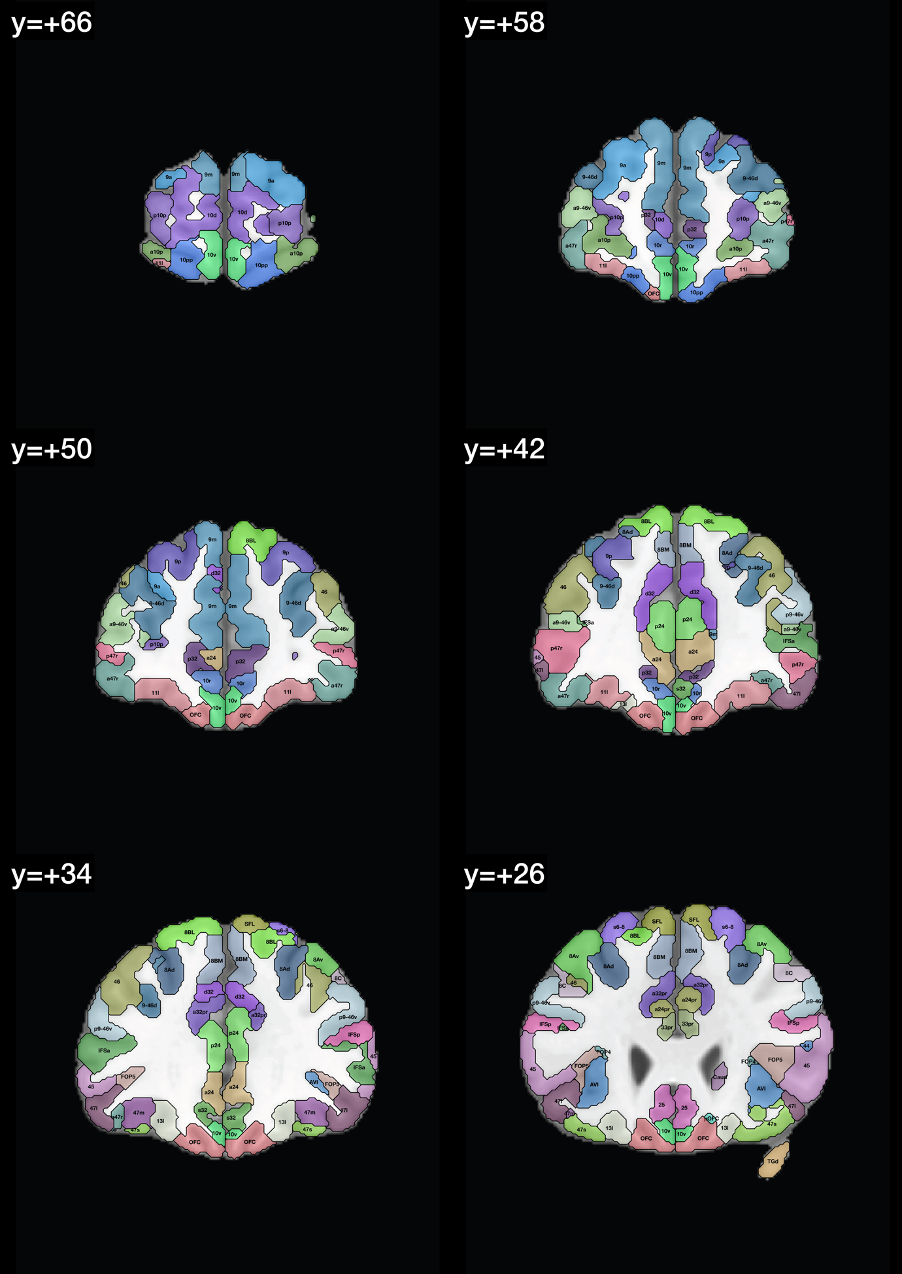
Fig. S1-2. Example coronal slices showing regions defined in the HCPex atlas and added subcortical regions (Huang et al. 2022). The abbreviations are as in Table S1. The y values for the coronal slices are in MNI coordinates.
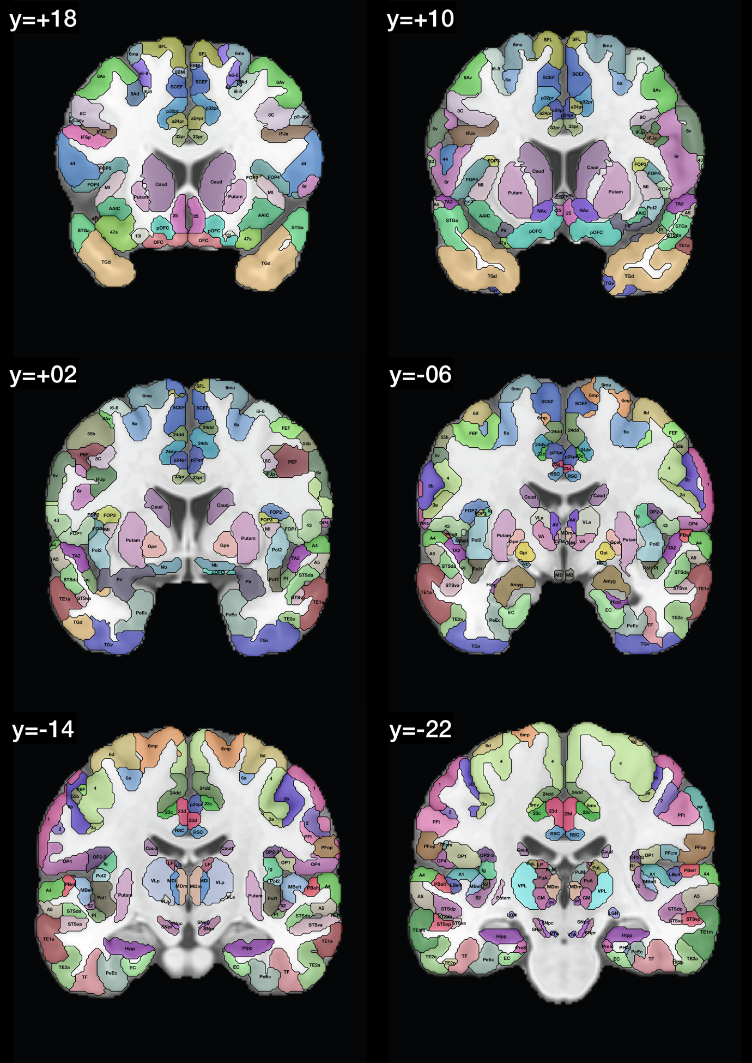
Fig. S1-3. Example coronal slices showing regions defined in the HCPex atlas and added subcortical regions (Huang et al. 2022). The abbreviations are as in Table S1. The y values for the coronal slices are in MNI coordinates.
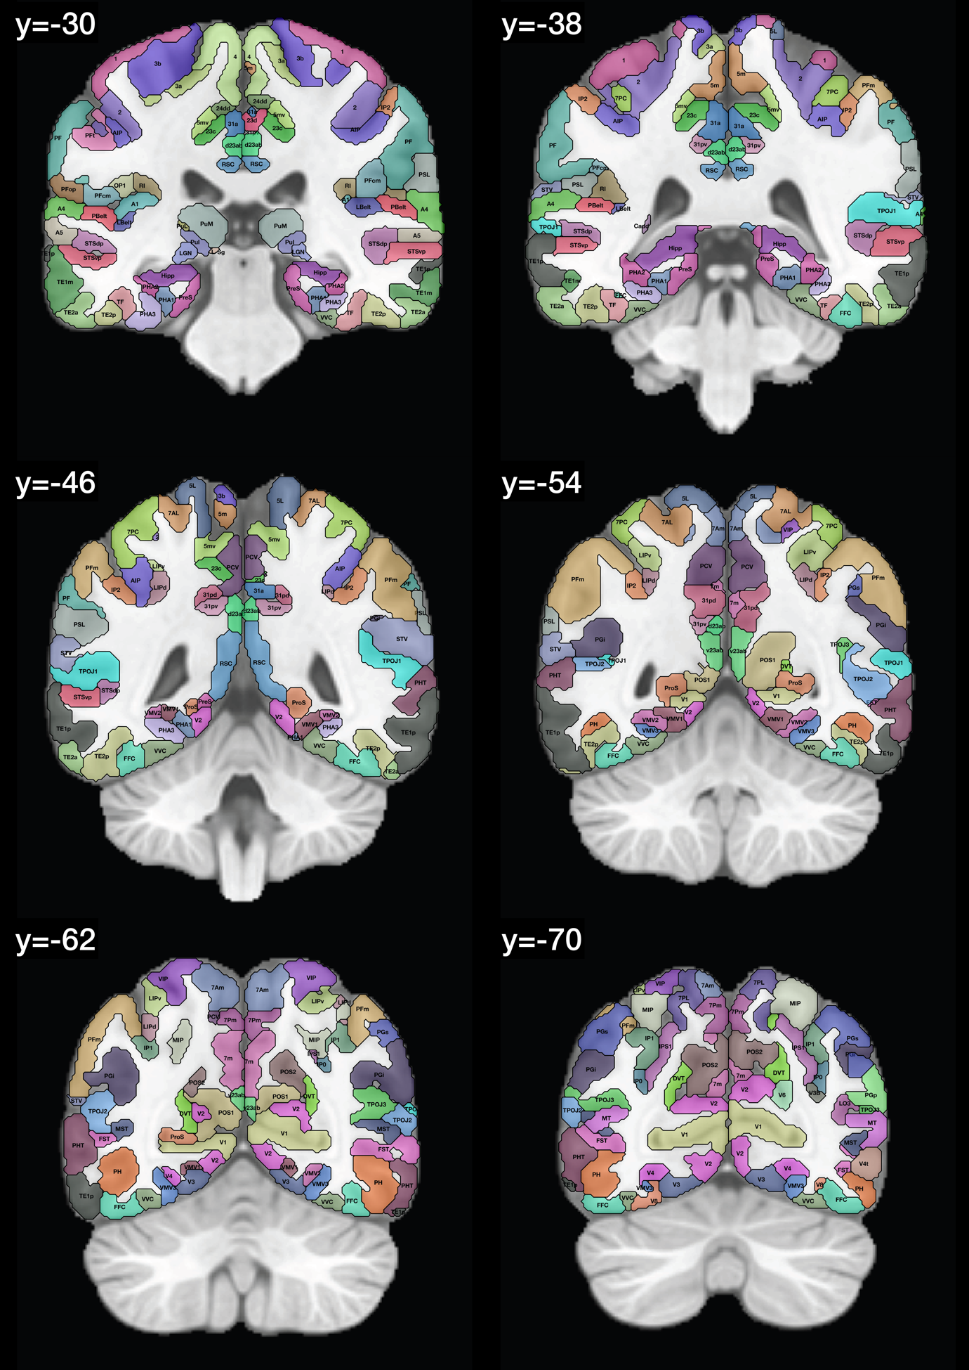
Fig. S1-4. Example coronal slices showing regions defined in the HCPex atlas and added subcortical regions (Huang et al. 2022). The abbreviations are as in Table S1. The y values for the coronal slices are in MNI coordinates.
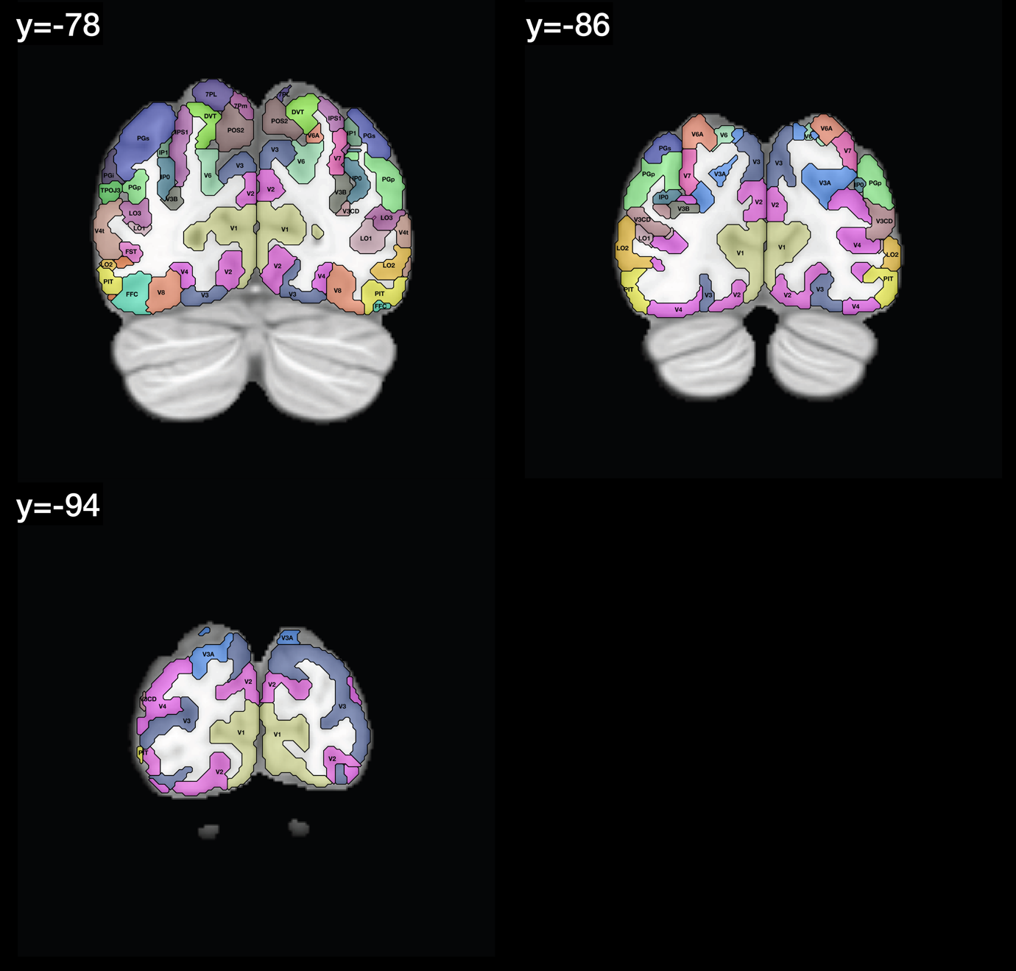

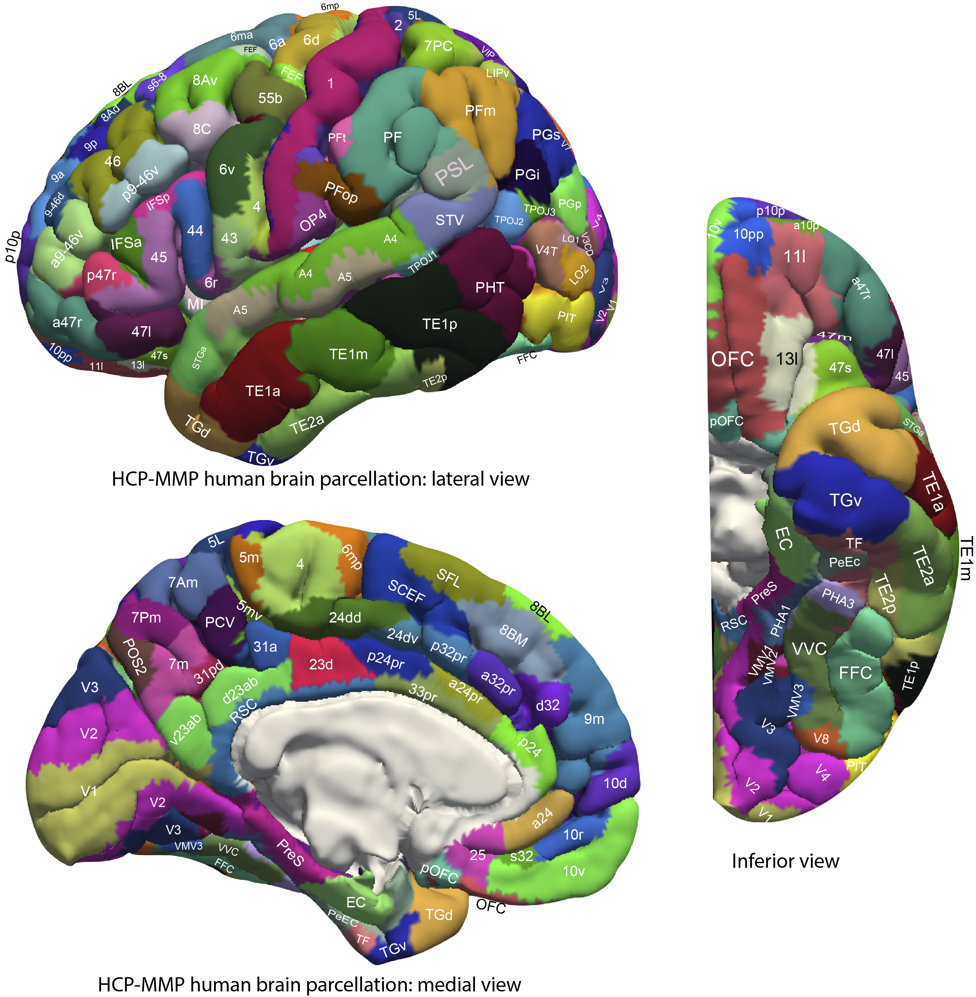
Fig. S1-5. Anatomical regions of the human visual and other cortical regions. Regions are shown as defined in the HCP-MMP atlas (Glasser et al. 2016), and in its extended version HCPex (Huang et al. 2022). The regions are shown on images of the human brain without the sulci expanded to show which cortical HCP-MMP regions are normally visible, for comparison with Figs. 6-10. (The ICBM153 MNI T1 image was used to prepare this figure.) Abbreviations are provided in Table S1.

Details of the Hopf Effective Connectivity algorithm used for the fMRI data
Introduction
Effective connectivity measures the effect of one brain region on another, and utilizes differences detected at different times in the signals in each connected pair of brain regions to infer effects of one brain region on another. One such approach is dynamic causal modelling, but is applied most easily to activation studies, and is typically limited to measuring the effective connectivity between just a few brain areas (Friston 2009; Valdes-Sosa et al. 2011; Bajaj et al. 2016), though there have been moves to extend it to resting state studies and more brain areas (Frassle et al. 2017; Razi et al. 2017). The method used (Rolls et al. 2022b, 2023c) was developed from a Hopf algorithm to enable measurement of generative effective connectivity between many brain areas, described by Deco et al (2019). A principle is that the functional connectivity is measured at time t and time t + tau, where tau is typically 2 s to take into account the time within which differences in the timing of BOLD signals can occur, and then the effective connectivity model is trained by error correction until it can generate the functional connectivity matrices at time t and time t + tau. Further details of the algorithm, and the development that enabled it to measure the effective connectivity in each direction, are described next.
To measure the effective connectivity, we use a whole-brain model that allows us to simulate the BOLD activity across all brain regions and time. We use the so-called Hopf computational model, which integrates the dynamics of Stuart-Landau oscillators, to enable the activity (in this case the BOLD signal) of each brain region to be generated from the underlying effective connectivity in both directions between every pair of brain regions (Deco et al. 2017b). As mentioned above, we include in the model 360 cortical brain areas (Huang et al. 2022). The local dynamics of each brain area (node) which simulate the BOLD signal are given by Stuart-Landau oscillators which express the normal form of a supercritical Hopf bifurcation, describing the transition from noisy to oscillatory dynamics (Kuznetsov 2013). During the last years, numerous studies were able to show how the Hopf whole-brain model successfully simulates empirical electrophysiology (Freyer et al. 2011; Freyer et al. 2012), MEG (Deco et al. 2017a) and fMRI (Kringelbach et al. 2015; Deco et al. 2017b; Kringelbach and Deco 2020).

Overview of the effective connectivity measurement algorithm
The steps of the algorithm can be summarized as follows:

1. From the empirically measured time series of the BOLD signal for each of N brain areas bandpass filtered between 0.008 and 0.08 Hz we calculate the NxN empirical functional connectivity matrix FC^{emp} by the Pearson correlation between the time series of each pair of brain regions. We also create an FC^{tau_emp} NxN lagged time series matrix in which the entry for each brain region is the correlation between the BOLD signal at time t and t+tau calculated over the whole empirical time series. Tau is typically set to 2 s, a minimal useful period in the BOLD signal in which a change can be detected. The lagged correlation matrix FC^{tau_emp} provides the delayed information that enables the effective connectivity to be measured in both directions between each pair of nodes.

2. The NxN effective connectivity (EC) matrix to be calculated can be initialized with zeros, or with a structural connectivity matrix obtained from for example diffusion MRI. The effective connectivity matrix is read by convention from column to row, with the effective connectivity between each pair of nodes (brain regions) 1:N in one direction shown in the lower left triangle, and the effective connectivity in the opposite direction in the upper right triangle. If the EC matrix is initialized with a structural connection matrix, this can have the potential advantage that nodes with no possible anatomical connection can be left at 0 and ignored in the calculations, which has the potential to increase the accuracy of the algorithm for a given number of nodes in the EC matrix, as fewer nodes need to be taken into consideration in calculating the updates to the EC matrix. If the EC matrix is initialized with zeros, this has the potential advantage that any errors in the structural connectivity matrix cannot influence the results. In practice, it has been found that with up to 360 brain areas and typical time series for the BOLD signal and structural connectivity matrices, the effective connectivity can be calculated as well with the initialization with zeros as with the structural connectivity initialization (with correlations between the ECs calculated in these two ways typically 0.99), and therefore the initialization with zeros is used in the work described, as it makes fewer assumptions.

3. The ‘natural oscillation frequency’ (or ‘intrinsic frequency’) of each brain region or node is measured as the frequency with the peak power from the power spectrum of the BOLD signal for each node.

4. A Stuart-Landau oscillatory system with the x oscillatory component for each of the N nodes (its ‘natural oscillation frequency’ measured from the BOLD signal) and the y oscillatory components provided with the same ‘natural oscillation frequency’ parameters is simulated with a Hopf model. The N oscillators are connected by the EC matrix, and noise is injected into the system so that it just oscillates. This oscillatory system is simulated to generate simulated BOLD signals for each of the N brain areas.

5. The EC matrix is then updated over a series of iterations using gradient descent. The error signal is the difference between FC, the simulated functional connectivity matrix from the current EC matrix, and FC^{emp}, the empirically measured functional connectivity matrix, together with the corresponding difference between the simulated FC^{tau} and the empirical FC^{tau_emp} matrix.

6. The EC matrix is that which has been computed when the correlations between the simulated and empirical FC matrices, and the simulated matrix FC^{tau} and the empirical FC^{tau_emp} are at their maximum, which are typically 0.75-0.8 after 50 iterations.

The Hopf whole brain model using Stuart-Landau oscillators
The Hopf whole-brain model, which integrates the activity of Stuart-Landau oscillators expressing the activity of each brain region i can be expressed mathematically as follows:

$\frac{dx_{i}}{dt}= \overset{Local Dynamics}{\overbrace{\left[a_{i}-x_{i}^{2}-y_{i}^{2}\right]x_{i}-ω_{i}y_{i}}} +\overset{Coupling }{ \overbrace{G\sum_{j=1}^{N}{C_{ij}}\left(x_{j}-x_{i}\right)}} +\overset{Gaussian Noise }{\overbrace{βη_{i}\left(t\right)}}$ (1)
$\frac{dy_{i}}{dt}= \left[a_{i}-x_{i}^{2}-y_{i}^{2}\right]y_{i}+ω_{i}x_{i} + G\sum_{j=1}^{N}{C_{ij}\left(y_{j}-y_{i}\right)} + βη_{i}\left(t\right)$ (2)

The pair ($x_{i}(t),y_{i}(t))$ represent the state of the dynamical system modelling brain area (node) i, given its interactions with all other brain areas, at a given time t. Equations 1 and 2 describe the dynamics of this system in Cartesian coordinates, where the $x_{i}(t)$ term represents the simulated BOLD signal data of brain area i. The values of $y_{i}(t)$ are relevant to the dynamics of the system but are not part of the information read out from the system.

Equations 1 and 2 describe the coupling of Stuart-Landau oscillators through an effective connectivity matrix C. In these equations, $η_{i}\left(t\right)$ provides additive Gaussian noise with standard deviation β. The Stuart-Landau oscillators for each brain area i expresses a Hopf normal form that has a supercritical bifurcation at $a_{i}$=0, so that if $a_{i}$>0 the system has a stable limit cycle with frequency $f_{i}$=$ω_{i}$/2π (where $ω_{i}$ is the angular velocity), and when $a_{i}$<0 the system has a stable fixed point representing a low activity noisy state. The intrinsic frequency $f_{i}$ of each Stuart-Landau oscillator corresponding to a brain area is in the 0.008–0.08 Hz band (i=1, …, 362). The intrinsic frequencies are fitted from the data, as given by the frequency with the peak power of the narrowband BOLD signals of each brain region. The coupling term in Equations 1 and 2 representing the input received in node i from every other node j, is weighted by the corresponding effective connectivity $C_{ij}$. The coupling is the canonical diffusive coupling, which approximates the simplest (linear) part of a general coupling function (Deco et al. 2019). G denotes the global coupling weight, scaling equally the total input received in each brain area. With the oscillators weakly coupled, the periodic orbit of the uncoupled oscillators is preserved.

Further insight can be obtained as follows. The local dynamics of each brain area are that of a Stuart-Landau oscillator, and in Equations 1 and 2 they are shown in Cartesian coordinates. However for insight into their dynamics they can be re-expressed in polar coordinates. This is performed by taking $r_{i}(t)$ to be $\sqrt{{x_{i}(t)}^{2}+{y_{i}(t)}^{2}}$, which can be interpreted as the amplitude of the Stuart-Landau oscillator modelling node i at time t, and $θ_{i}(t)$ to be $arctan⁡\left(\frac{y_{i}(t)}{x_{i}(t)}\right)$, which can be interpreted as the angle by which the oscillator for node i has rotated by time t. The coordinate transform yields the following equations for the local dynamics: ${\dot{r}}_{i}=\left(a_{i}-{r_{i}}^{2}\right)r_{i}, {\dot{θ}}_{i}=ω_{i}$. Hence the local dynamics of each brain region have a rate of change of $θ$ with respect to time (a rate of oscillation) that is constant. Similarly, we see that the rate of change of amplitude with respect to time will vanish if and only if $r_{i}$=0 or $r_{i}=\sqrt{a_{i}}$, (clearly only possible if $a_{i}≥0)$. On closer inspection of the equation governing $r_{i}$ we see for $a_{n}≤$0 that${\dot{r}}_{i}$ is strictly negative for all non-zero values of $r_{i}$, hence the system converges towards a state of no amplitude. For $a_{n}>$0 we see that for all non-zero values of $r_{i}$ that ${\dot{r}}_{i}$ is strictly negative for $r_{i}>\sqrt{a_{i}}$ and strictly positive for $r_{i}<\sqrt{a_{i}}$, so all systems that are initialised with a non-zero amplitude converge to a state where $r_{i}=\sqrt{a_{i}}$.

To put this more formally, the system undergoes a supercritical bifurcation at $a_{i}$=0, so that if $a_{i}$>0 the system has a stable limit cycle given by $r_{i}=\sqrt{a_{i}},$ ${\dot{θ}}_{i}=ω_{i}$ (with frequency $f_{i}=ω_{i}/2π$), and if $a_{i}$<0 the system has a stable fixed point $r_{i}=0$. However, such asymptotic stability of the model is rather unrealistic. The value of $β$ in the Hopf whole-brain model is the standard deviation of the Gaussian noise, and this is chosen to be sufficiently high that for a value of $a_{i}$ close to the bifurcation point, such asymptotic stability is avoided. The intrinsic frequency $f_{i}$ for each brain region is determined as follows. For each brain area i, the empirical time-series data is averaged across participants and through a discrete Fourier transform the modal frequency (that with the peak power), with the exclusion of high frequency noise, is obtained and set to be the intrinsic frequency of the given brain area. The intrinsic frequency $f_{i}$ of each Stuart-Landau oscillator corresponding to a brain area is in the 0.008–0.08 Hz band (i=1, …, 360).

The coupling term in Equations 1 and 2 acts to align the phases and frequencies of the oscillators in connected brain regions, and represents the input received in node i from every other node j and is weighted by the corresponding effective connectivity $C_{ij}$. The $(x_{j}-x_{i})$ term acts to force the dynamics of brain region i to more closely match and indeed synchronise with brain region j (with $C_{ij}$ > 0).

Gradient descent to optimize the effective connectivity matrix
The effective connectivity matrix is found by gradient descent from its initial value, informed by errors in functional connectivity predictions made using the Hopf model from the current effective connectivity matrix. The gradient descent is performed in order to fit the simulated to the empirical functional connectivity (FC) pairs and the lagged FC(tau) pairs. By this, we are able to infer a non-symmetric Effective Connectivity matrix (see Gilson et al (2016)). Note that FC^{tau}, ie the lagged functional connectivity between pairs, lagged at tau s, breaks the symmetry and thus is fundamental for our purpose. Specifically, we compute the distance between the simulated model FC and empirical data FC^{emp}, as well as the simulated model FC^{tau} and data FC^{tau_emp} and adjust each effective connection (entry in the effective connectivity matrix) separately with a gradient-descent approach. The model is run repeatedly with the updated effective connectivity until the fit converges towards a stable value. The update rule for an entry $C_{ij}$in the effective connectivity matrix is

$C_{ij}=C_{ij}+ε\left(FC_{ij}^{emp}-FC_{ij}^{ }+FC_{ij}^{tau_emp}-FC_{ij}^{tau}\right)$ (3)
where $ϵ is$a learning rate constant, and i and j are the nodes.
For the implementation, we set tau to be 2 s, selecting the appropriate number of TRs to achieve this.
The convergence of the algorithm is illustrated elsewhere (Huang et al. 2021). The correlations between the empirical functional connectivities and those simulated from the estimated effective connectivities for both time t and t+tau reach values close to 0.8.

Interpretation of the effective connectivity measured by the Hopf algorithm
If the Hopf effective connectivity algorithm is used with an anatomical connectivity mask, then the effective connectivity for anatomically unconnected nodes (brain areas) is not updated by the effective connectivity algorithm. This enables the algorithm to measure what might be termed ‘anatomical effective connectivity’. We note that in practice the anatomical maps measured with diffusion tractography are not very sparse, so that only some links are not included in the effective connectivity map that is produced. We also note that if there are any errors in the diffusion tractography connection matrix, for example some missing anatomical connection links, then those links will not be included in the effective connectivity map.
If the Hopf effective connectivity algorithm is initialized with zeros, then all connectivities in the matrix can be updated by the algorithm. This ensures that there are no errors in the effective connectivity map that is generated by the algorithm due to any imperfections in the anatomical connection matrix. The effective connectivity calculated in this way reflects signals in one part of the brain that follow signals in another part of the brain with a time delay that is termed here τ (tau), independently of whether there is a direct anatomical connection or not. This is analogous to dynamic causal modelling and most applications of Granger causality to brain connectivity (Friston et al. 2014; Bajaj et al. 2016; Frassle et al. 2017; Razi et al. 2017), which impose no anatomical constraints on possible pathways between the nodes, i.e. the brain regions.
In practice, we have found that with the anatomical connection map we generated using diffusion tractography (Huang et al. 2021), which is not very sparse, the effective connectivity matrices generated when starting with the anatomical connection matrix and the initial matrix with zeros are very similar, with typical correlations of 0.98. This is reassuring, and indicates that possible imperfections in the anatomical connection map do not produce problems in the effective connectivity matrix; and correspondingly that the Hopf effective connectivity algorithm assigns zero or close to zero effective connectivities when there is no known anatomical connection between a pair of brain regions. If a different very sparse anatomical connection matrix was used to initialize the Hopf effective connectivity algorithm, then the correlation might be lower. In practice, we prefer the initialization with the zeros in the connection matrix, as is makes fewer assumptions, but we always check the results when the algorithm is initialized with an anatomical map. Further evidence is presented elsewhere (Rolls et al. 2022a).
The effective connectivity described here estimates an effect of one brain region on another measured by time-delayed analyses. However, effective connectivity in a backward or top-down direction in a hierarchy should not be interpreted as showing that what is represented at the top of the hierarchy is transferred to lower levels (Rolls 2016, 2021). For example, face cells were discovered in the primate inferior temporal visual cortex (Perrett et al. 1979; Perrett et al. 1982; Rolls 2000) and have large receptive fields of e.g. 78º in diameter (Rolls et al. 2003), yet V1 neurons respond to bars or edges and have receptive fields that are in the order of 1º in diameter (Hubel and Wiesel 1968). Instead, the backprojections are important in computations such as memory recall and top-down attention (Rolls 2016, 2021), which although involving cortico-cortical backwards or top-down effective connectivity, do not require that what is represented high in the hierarchy is transferred to low levels in a cortico-cortical hierarchy.

Validation of the Hopf Effective Connectivity algorithm
First, the performance of the Hopf Effective Connectivity algorithm was evaluated in a brain system in which the connectivity is relatively well understood using anatomy in non-human primates. In particular, it is expected that there is a hierarchy from V1 to V2 to V3 to V4 (Felleman and Van Essen 1991; Markov et al. 2013; Markov and Kennedy 2013; Markov et al. 2014a; Markov et al. 2014b; Rolls 2016). The results for the Hopf effective connectivity algorithm applied for the first 17 visual areas in the HCP-MMP as shown in Fig. S1-6 of Rolls et al (2023b) provide evidence that the algorithm is working appropriately, with for example strong connectivity from V1 to V2, from V2 to V3, and from V3 to V4. In addition, the connectivity is generally stronger in this ‘forward’ direction between these pairs of early visual cortical regions than in the reverse direction, which is as expected given for example that the backprojections terminate generally on the apical dendrites in layer 1 far from the cell body (Markov et al. 2013; Markov and Kennedy 2013; Markov et al. 2014a; Markov et al. 2014b; Rolls 2016); and that the forward projection effects should dominate so the inputs from the world can proceed up the hierarchy, with the backprojections used in contrast for memory recall and top-down attention (Rolls 2016, 2021). Further, V1 connects strongly to V2, less to V3, and less to V4 (Fig. S1-6 of Rolls et al (2023b)).
Second, the mean effective connectivity for regions within a hemisphere is greater than the mean effective connectivity for regions to the contralateral regions, with the ratio for the contralateral to ipsilateral visual cortical regions 63%, and for language regions which are expected to be more lateralised 24% (Rolls et al. 2022a). This is as expected, given the typical specialization of the left hemisphere for language.
Third, a feature of the effective connectivities is that they are generally strongest to the exact corresponding brain region contralaterally. This is illustrated in Figs. S2 and S3 of Rolls et al (2023b) for most of the visual cortical regions. This attests to the efficacy of the effective connectivity algorithm, for it detects corresponding particular brain regions in the contralateral hemisphere, from all the 180 brain regions in the contralateral hemisphere.
Fourth, in all cases the 360x360 effective connectivity matrix could be used to generate by simulation 360x360 functional connectivity matrices for time t and time t + tau that were correlated 0.8 or more with the empirically measured functional connectivity matrices at time t and time t + tau using fMRI.
Fifth, the effective connectivity matrices were robust with respect to the number of participants, in that when the 171 participants were separated into two groups, the correlation between the effective connectivities measured for each group independently was 0.98.

Directionality of the effective connectivity when measured with fMRI
The directionality of the effective connectivity shown here is that which would be expected for transmission up through each sensory hierarchy, and is consistent with what has been shown on effective connectivity between the 360 cortical regions in the HCP-MMP parcellation (Glasser et al. 2016; Huang et al. 2022) in previous papers (Rolls et al. 2022a; Rolls et al. 2022b; Rolls et al. 2023a, 2023b; Rolls et al. 2023e, 2023d, 2023c; Rolls et al. 2023g). This directionality is supported by the effective connectivity measured in the ventral visual stream with the identical Stuart-Landau / Hopf generative effective connectivity algorithm used here but with the much faster method of magnetoencephalography (MEG) with HCP data from the working memory task with faces and tools as the visual stimuli (Larson-Prior et al. 2013), with a TR=20 ms and a tau of 20 ms. The measurement with MEG, and the latencies of the activations of different ventral visual stream regions, shows that the effective connectivity is in the expected hierarchical direction V1 > V2 > V4 > posterior inferior temporal visual cortex > anterior temporal lobe (Rolls et al. 2023f). With the much slower fMRI data, tau is set to 2 s, the measured directionality with the algorithm used here, and with the simpler linear algorithm (Gilson et al. 2016), is the reverse of what would be expected for the rapid transmission of information in the first 200 ms up a sensory hierarchy. Consistent with what we have found, with the BOLD signal in humans with the closely related but linear algorithm (Gilson et al. 2016), the effective connectivity measured from V2 to V1 is greater than from V1 to V2; and the effective connectivity from V3 to V2 is greater than from V2 to V3 (Gravel et al. 2020). The reasons for why the measurement of effective connectivity with fMRI data is in the opposite direction to the rapid forward cortico-cortical information transmission normally expected up each sensory hierarchy are not clear. One possibility is about how the fMRI BOLD signal relates to the preceding neuronal activity (Logothetis et al. 2001; Buzsaki et al. 2007). A second hypothesis (Rolls et al. 2023f) is that when stimuli are presented there is a rapid forward transmission of information up each cortical hierarchy within the first 200 ms, and that after that, activity continues in memory-related and other higher cortical areas, providing a long period in which there are top-down effects on earlier cortical areas, which are then what are measured with the rather slow fMRI BOLD signal when measurement times for the effective connectivity are in the order of 2 s as set by the tau used for the time delays with which the directionality is measured.
We further note that the directionality measured with the Hopf generative effective connectivity algorithm is consistent with that measured with other methods that utilise time delays to estimate directionality, such as Granger causality (Ge et al. 2012; Luo et al. 2013). Whereas Granger causality can be used to measure the time delayed effects separately between each pair of brain regions, a potential advantage of the generative effective connectivity algorithm used here is that this algorithm takes into account the connectivity between every pair of brain regions to generate the effective connectivity matrix between every brain region that best can generate the empirically measured functional connectivity and delayed functional connectivity across all of the brain regions. This is likely to have much less redundancy than measuring Granger causality between each pair of brain regions separately, and indeed the effective connectivity matrix between 360 cortical regions has reasonable sparseness or dilution of 0.11.
We also note that generative effective connectivity, even independently of sign, is a very useful measure of brain function, because it provides a measure of how much each brain region influences all other brain regions, which is potentially more useful in understanding brain function than the correlations measured by functional connectivity (Rolls 2023).

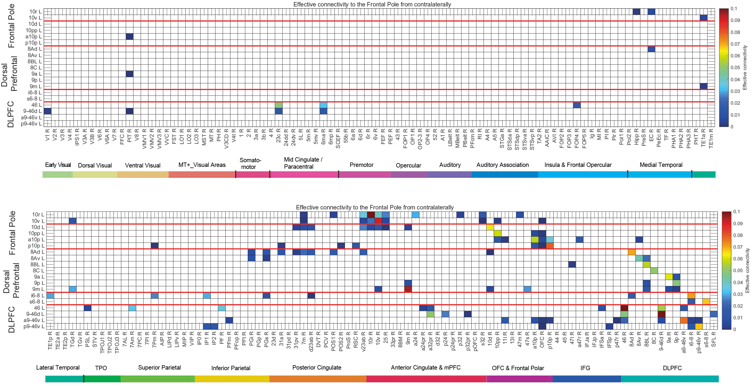
Fig. S2. Effective connectivity to the Left frontal cortical regions from all 180 cortical areas in the Right hemisphere. All effective connectivities greater than 0 are shown, and effective connectivities of 0 are shown as a blank. The connectivities from the first set of cortical regions are shown above, and from the second set below, etc. Conventions as in Fig. 2. Abbreviations: see Table S1. The effective connectivity is read from column to row. (ECtoFrontalPcontrars.eps)

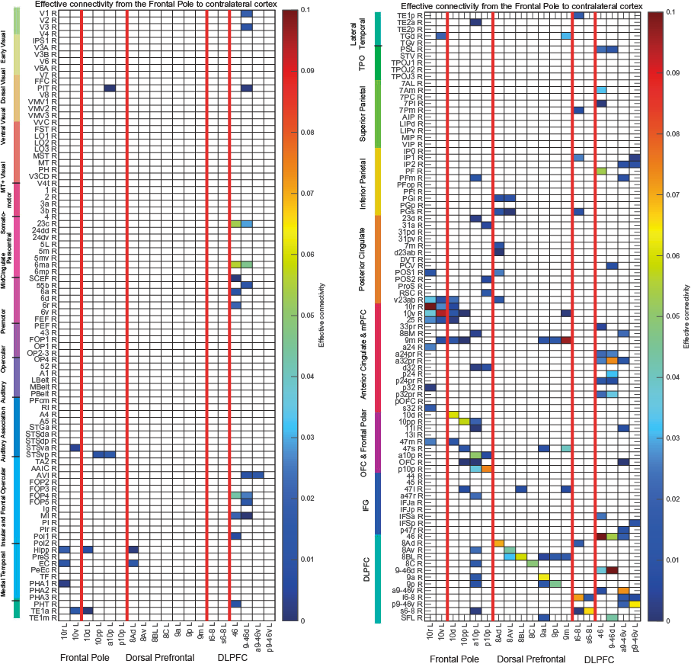
Fig. S3. Effective connectivity (EC) from the Left Frontal Cortical Regions to all 180 cortical areas in the Right hemisphere. All effective connectivities greater than 0 are shown, and effective connectivities of 0 are shown as a blank. The connectivities to the first set of cortical regions are shown on the left, and to the second set on the right. Conventions: see Fig. 2. Abbreviations: see Table S1. The effective connectivity is read from column to row. (ECfromFrontalPcontrars.eps)

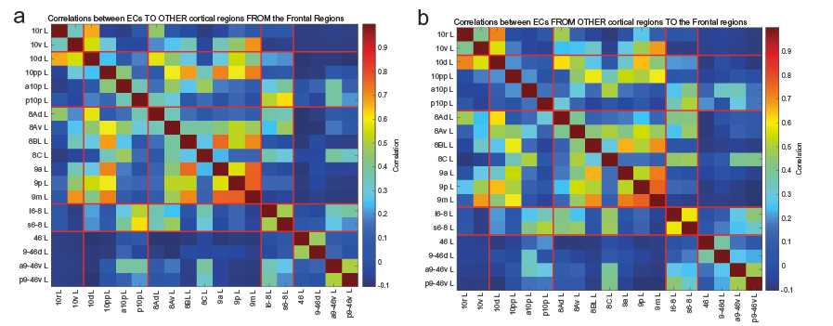
Fig. S4. a. Correlations between the effective connectivities TO other cortical regions FROM different Frontal Cortical Regions. b. Correlations between the effective connectivities FROM other cortical regions TO different Frontal Cortical Regions. The colours in the matrix show the correlations between pairs of cortical regions in the effective connectivities of each of the pair of brain regions with all 179 other cortical regions in the same hemisphere. Abbreviations: see Table S1. Grouping conventions for the red lines as in Fig. 2.

References

Bajaj S, Adhikari BM, Friston KJ, Dhamala M. 2016. Bridging the gap: Dynamic Causal Modeling and Granger Causality analysis of resting state functional magnetic resonance imaging. Brain Connect 6:652-661.
Buzsaki G, Kaila K, Raichle M. 2007. Inhibition and brain work. Neuron 56:771-783.
Deco G, Cabral J, Woolrich MW, Stevner ABA, van Hartevelt TJ, Kringelbach ML. 2017a. Single or multiple frequency generators in on-going brain activity: A mechanistic whole-brain model of empirical MEG data. Neuroimage 152:538-550.
Deco G, Cruzat J, Cabral J, Tagliazucchi E, Laufs H, Logothetis NK, Kringelbach ML. 2019. Awakening: Predicting external stimulation to force transitions between different brain states. Proceedings of the National Academy of Sciences 116:18088-18097.
Deco G, Kringelbach ML, Jirsa VK, Ritter P. 2017b. The dynamics of resting fluctuations in the brain: metastability and its dynamical cortical core. Sci Rep 7:3095.
Felleman DJ, Van Essen DC. 1991. Distributed hierarchical processing in the primate cerebral cortex. Cereb Cortex 1:1-47.
Frassle S, Lomakina EI, Razi A, Friston KJ, Buhmann JM, Stephan KE. 2017. Regression DCM for fMRI. Neuroimage 155:406-421.
Freyer F, Roberts JA, Becker R, Robinson PA, Ritter P, Breakspear M. 2011. Biophysical mechanisms of multistability in resting-state cortical rhythms. J Neurosci 31:6353-6361.
Freyer F, Roberts JA, Ritter P, Breakspear M. 2012. A canonical model of multistability and scale-invariance in biological systems. PLoS Comput Biol 8:e1002634.
Friston K. 2009. Causal modelling and brain connectivity in functional magnetic resonance imaging. PLoS Biol 7:e33.
Friston KJ, Kahan J, Biswal B, Razi A. 2014. A DCM for resting state fMRI. Neuroimage 94:396-407.
Ge T, Feng J, Grabenhorst F, Rolls ET. 2012. Componential Granger causality, and its application to identifying the source and mechanisms of the top-down biased activation that controls attention to affective vs sensory processing. Neuroimage 59:1846-1858.
Gilson M, Moreno-Bote R, Ponce-Alvarez A, Ritter P, Deco G. 2016. Estimation of directed effective connectivity from fMRI functional connectivity hints at asymmetries in the cortical connectome. PLoS Comput Biol 12:e1004762.
Glasser MF, Coalson TS, Robinson EC, Hacker CD, Harwell J, Yacoub E, Ugurbil K, Andersson J, Beckmann CF, Jenkinson M, Smith SM, Van Essen DC. 2016. A multi-modal parcellation of human cerebral cortex. Nature 536:171-178.
Gravel N, Renken RJ, Harvey BM, Deco G, Cornelissen FW, Gilson M. 2020. Propagation of BOLD activity reveals task-dependent directed interactions across human visual cortex. Cereb Cortex 30:5899-5914.
Huang C-C, Rolls ET, Hsu C-CH, Feng J, Lin C-P. 2021. Extensive cortical connectivity of the human hippocampal memory system: beyond the "what" and "where" dual-stream model. Cereb Cortex 31:4652-4669.
Huang CC, Rolls ET, Feng J, Lin CP. 2022. An extended Human Connectome Project multimodal parcellation atlas of the human cortex and subcortical areas. Brain Struct Funct 227:763-778.
Hubel DH, Wiesel TN. 1968. Receptive fields and functional architecture of macaque monkey striate cortex. J Physiol 195:215-243.
Kringelbach ML, Deco G. 2020. Brain states and transitions: insights from computational neuroscience. Cell Rep 32:108128.
Kringelbach ML, McIntosh AR, Ritter P, Jirsa VK, Deco G. 2015. The rediscovery of slowness: exploring the timing of cognition. Trends Cogn Sci 19:616-628.
Kuznetsov YA. 2013. Elements of applied bifurcation theory. New York: Springer Science and Business Media.
Larson-Prior LJ, Oostenveld R, Della Penna S, Michalareas G, Prior F, Babajani-Feremi A, Schoffelen JM, Marzetti L, de Pasquale F, Di Pompeo F, Stout J, Woolrich M, Luo Q, Bucholz R, Fries P, Pizzella V, Romani GL, Corbetta M, Snyder AZ, Consortium WU-MH. 2013. Adding dynamics to the Human Connectome Project with MEG. Neuroimage 80:190-201.
Logothetis NK, Pauls J, Augath M, Trinath T, Oeltermann A. 2001. Neurophysiological investigation of the basis of the fMRI signal. Nature 412:150-157.
Luo Q, Ge T, Grabenhorst F, Feng J, Rolls ET. 2013. Attention-dependent modulation of cortical taste circuits revealed by Granger causality with signal-dependent noise PLoS Comput Biol 9:e1003265.
Markov NT, Ercsey-Ravasz M, Van Essen DC, Knoblauch K, Toroczkai Z, Kennedy H. 2013. Cortical high-density counterstream architectures. Science 342:1238406.
Markov NT, Ercsey-Ravasz MM, Ribeiro Gomes AR, Lamy C, Magrou L, Vezoli J, Misery P, Falchier A, Quilodran R, Gariel MA, Sallet J, Gamanut R, Huissoud C, Clavagnier S, Giroud P, Sappey-Marinier D, Barone P, Dehay C, Toroczkai Z, Knoblauch K, Van Essen DC, Kennedy H. 2014a. A weighted and directed interareal connectivity matrix for macaque cerebral cortex. Cereb Cortex 24:17-36.
Markov NT, Kennedy H. 2013. The importance of being hierarchical. Curr Opin Neurobiol 23:187-194.
Markov NT, Vezoli J, Chameau P, Falchier A, Quilodran R, Huissoud C, Lamy C, Misery P, Giroud P, Ullman S, Barone P, Dehay C, Knoblauch K, Kennedy H. 2014b. Anatomy of hierarchy: feedforward and feedback pathways in macaque visual cortex. J Comp Neurol 522:225-259.
Perrett DI, Rolls ET, Caan W. 1979. Temporal lobe cells of the monkey with visual responses selective for faces. Neurosci Lett S3:S358.
Perrett DI, Rolls ET, Caan W. 1982. Visual neurons responsive to faces in the monkey temporal cortex. Exp Brain Res 47:329-342.
Razi A, Seghier ML, Zhou Y, McColgan P, Zeidman P, Park HJ, Sporns O, Rees G, Friston KJ. 2017. Large-scale DCMs for resting-state fMRI. Netw Neurosci 1:222-241.
Rolls ET. 2000. Functions of the primate temporal lobe cortical visual areas in invariant visual object and face recognition. Neuron 27:205-218.
Rolls ET. 2016. Cerebral Cortex: Principles of Operation. Oxford: Oxford University Press.
Rolls ET. 2021. Brain Computations: What and How. Oxford: Oxford University Press.
Rolls ET. 2023. Brain Computations and Connectivity. Oxford: Oxford University Press. Open Access.
Rolls ET, Aggelopoulos NC, Zheng F. 2003. The receptive fields of inferior temporal cortex neurons in natural scenes. J Neurosci 23:339-348.
Rolls ET, Deco G, Huang C-C, Feng J. 2022a. The human language effective connectome. Neuroimage 258:119352.
Rolls ET, Deco G, Huang C-C, Feng J. 2023a. Human amygdala compared to orbitofrontal cortex connectivity, and emotion. Prog Neurobiol 220:102385.
Rolls ET, Deco G, Huang C-C, Feng J. 2023b. Multiple cortical visual streams in humans. Cereb Cortex 33:3319-3349.
Rolls ET, Deco G, Huang CC, Feng J. 2022b. The effective connectivity of the human hippocampal memory system. Cereb Cortex 32:3706-3725.
Rolls ET, Deco G, Huang CC, Feng J. 2023c. The human orbitofrontal cortex, vmPFC, and anterior cingulate cortex effective connectome: emotion, memory, and action. Cereb Cortex 33:330-359.
Rolls ET, Deco G, Huang CC, Feng J. 2023d. The human posterior parietal cortex: effective connectome, and its relation to function. Cereb Cortex 33:3142-3170.
Rolls ET, Deco G, Huang CC, Feng J. 2023e. Prefrontal and somatosensory-motor cortex effective connectivity in humans. Cereb Cortex 33:4939-4963.
Rolls ET, Deco G, Zhang Y, Feng J. 2023f. Hierarchical organisation of the human ventral visual streams revealed with magnetoencephalography. Cereb Cortex:doi: 10.1093/cercor/bhad1318.
Rolls ET, Rauschecker JP, Deco G, Huang CC, Feng J. 2023g. Auditory cortical connectivity in humans. Cereb Cortex 33:6207-6227.
Valdes-Sosa PA, Roebroeck A, Daunizeau J, Friston K. 2011. Effective connectivity: influence, causality and biophysical modeling. Neuroimage 58:339-361.

